Terraform Tasks – Solutions Document

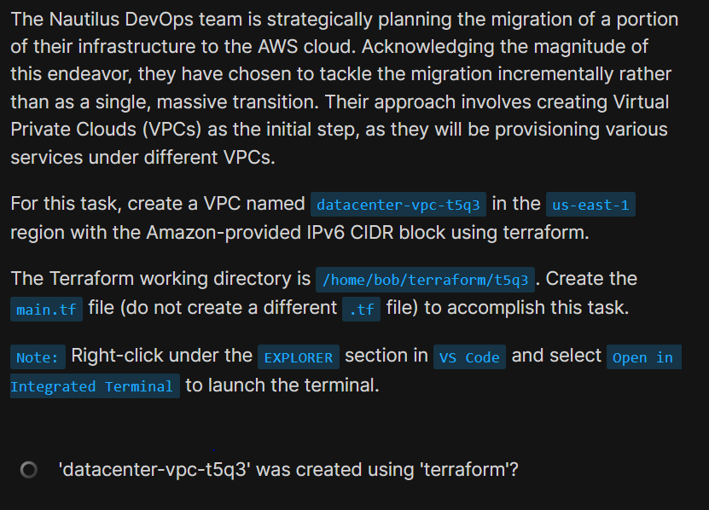
Task: Create VPC with IPv6 (t5q3)
resource "aws_vpc" "t5q3_vpc" {
cidr_block = "10.0.0.0/16"
assign_generated_ipv6_cidr_block = true
tags = {
Name = "datacenter-vpc-t5q3"
}
}
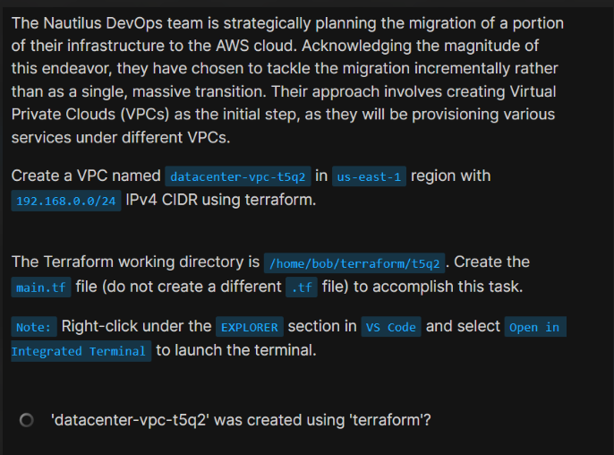

Task: Create VPC with IPv4 CIDR (t5q2)
provider "aws" {
region = "us-east-1"
}
resource "aws_vpc" "t5q2_vpc" {
cidr_block = "192.168.0.0/24"
tags = {
Name = "datacenter-vpc-t5q2"
}
}
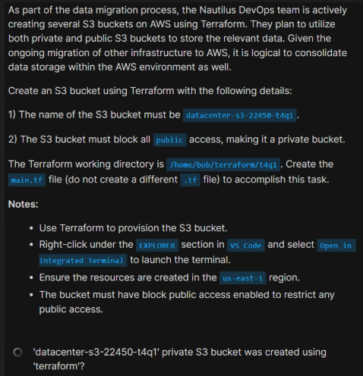

Task: Create Private S3 Bucket (t4q1)
resource "aws_s3_bucket" "private_bucket" {
bucket = "datacenter-s3-22450-t4q1"
}
resource "aws_s3_bucket_public_access_block" "block_public" {
bucket = aws_s3_bucket.private_bucket.id
block_public_acls = true
block_public_policy = true
ignore_public_acls = true
restrict_public_buckets = true
}
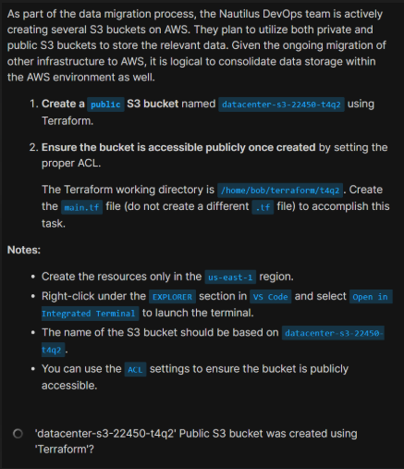

Task: Create Public S3 Bucket (t4q2)
resource "aws_s3_bucket" "public_bucket" {
bucket = "datacenter-s3-22450-t4q2"
}
resource "aws_s3_bucket_acl" "public_acl" {
bucket = aws_s3_bucket.public_bucket.id
acl = "public-read"
}
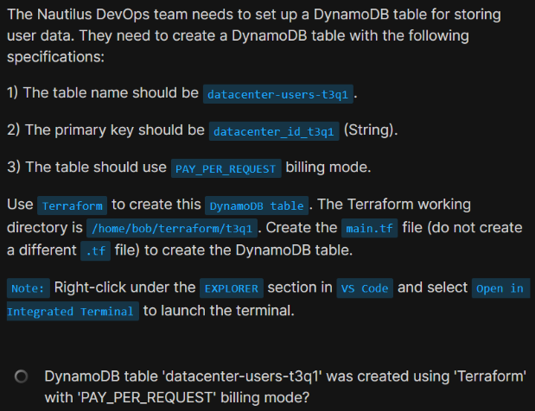

Task: DynamoDB Table (t3q1)
resource "aws_dynamodb_table" "users_table" {
name = "datacenter-users-t3q1"
billing_mode = "PAY_PER_REQUEST"
hash_key = "datacenter_id_t3q1"
attribute {
name = "datacenter_id_t3q1"
type = "S"
}
}
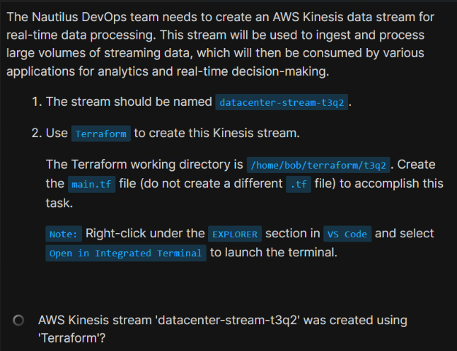

Task: Kinesis Stream (t3q2)
resource "aws_kinesis_stream" "stream" {
name = "datacenter-stream-t3q2"
shard_count = 1
retention_period = 24
}
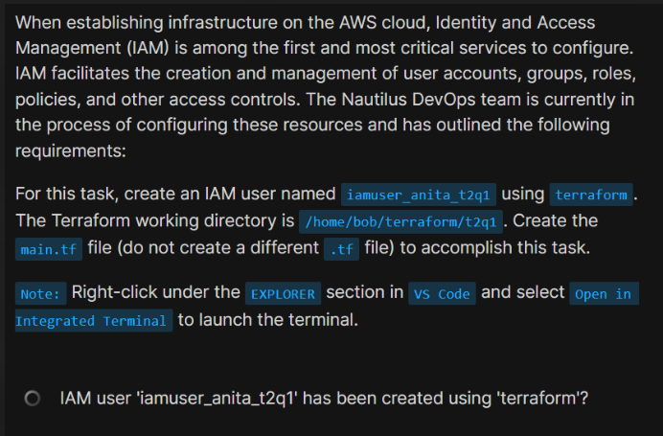

Task: IAM User (t2q1)
resource "aws_iam_user" "user" {
name = "iamuser_anita_t2q1"
}
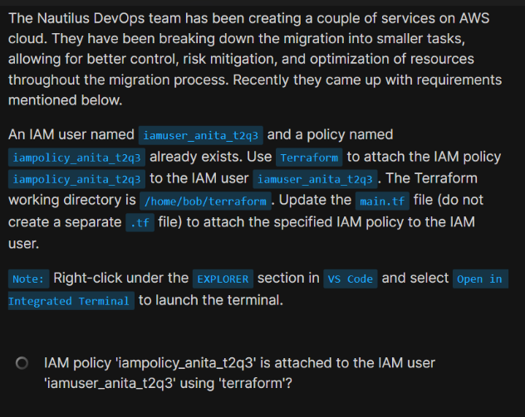

Task: Attach IAM Policy (t2q3)
resource "aws_iam_user_policy_attachment" "attach_policy" {
user = "iamuser_anita_t2q3"
policy_arn = "arn:aws:iam::aws:policy/iampolicy_anita_t2q3"
}
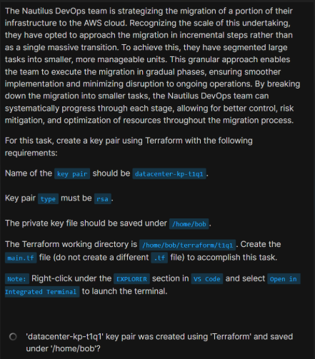

Task: Create Key Pair (t1q1)
resource "tls_private_key" "rsa_key" {
algorithm = "RSA"
rsa_bits = 2048
}
resource "aws_key_pair" "kp" {
key_name = "datacenter-kp-t1q1"
public_key = tls_private_key.rsa_key.public_key_openssh
}
resource "local_file" "private_key" {
filename = "/home/bob/datacenter-kp-t1q1.pem"
content = tls_private_key.rsa_key.private_key_pem
}
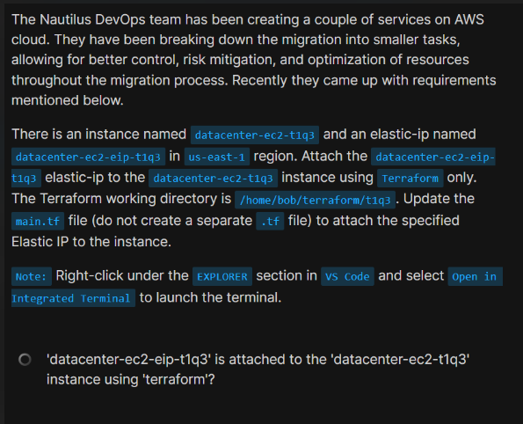

Task: Attach Elastic IP (t1q3)
data "aws_instance" "target_instance" {
filter {
name = "tag:Name"
values = ["datacenter-ec2-t1q3"]
}
}
data "aws_eip" "target_eip" {
filter {
name = "tag:Name"
values = ["datacenter-ec2-eip-t1q3"]
}
}
resource "aws_eip_association" "eip_assoc" {
instance_id = data.aws_instance.target_instance.id
allocation_id = data.aws_eip.target_eip.id
}

